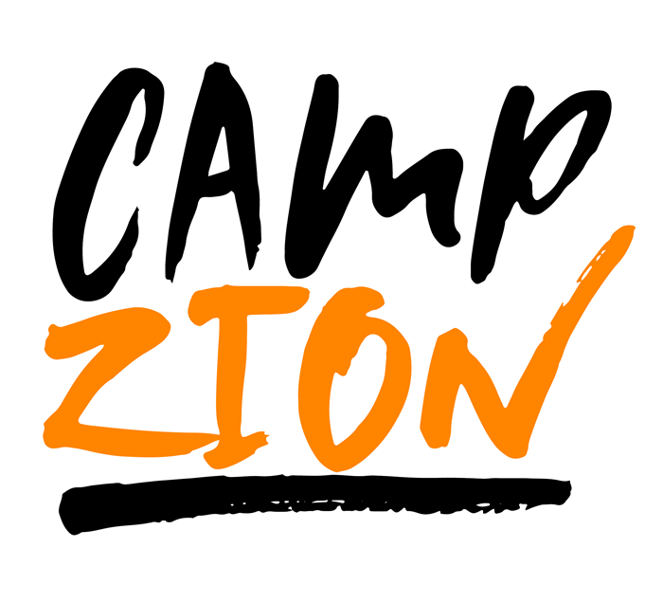

Camp Zion is a summer day camp that offers a unique,
engaging, and fun summer experience for children
entering the 1st-9th grades. Camp Zion focuses on
enriching a child’s biblical knowledge, strengthening
academic skills, developing character, building new
relationships and having the most fun possible. Daily
chapel, academics, exercise, physical activities, leadership sessions and elective classes will have your children begging for more year after year.

